FIT BUDDY AI
8-Phase Project Documentation
AI Fitness Plan Generator using Gemini Models
Project Category: Generative AI
Team Leader: Mariya Darshini (25ds022)
Team Members: S. Harini (25ds016), R. Subhashri (25ds041), S. Mythili (25ds024)
Technology: FastAPI, Google Gemini, SQLAlchemy, SQLite, Jinja2
GitHub: https://github.com/Mariyadarshini/fitbuddy-ai

How the project follows the 8 phases
Phase | Title | Main Evidence
1 | Brainstorming & Idea Generation | Idea, problem, proposed solution, selection rationale
2 | Requirement Analysis | Problem statement, functional/non-functional, software/hardware/user requirements
3 | Project Design | Architecture, modules, UI, data design, flowchart and algorithm
4 | Project Planning | WBS, timeline, task allocation, milestones and risk log
5 | Project Development | Actual source code, folders, Gemini integration and working UI
6 | Project Testing | test_app.py, test cases, validation, fixes and outputs
7 | Project Documentation | README, report, diagrams, screenshots and references
8 | Project Demonstration | Working website flow, plan outputs and demo-video link

PHASE 1 – Brainstorming & Idea Generation

1.1 Project Idea
FitBuddy AI is a Generative AI-powered fitness planning web application. It helps users create a personalized 7-day workout plan and a nutrition or recovery tip based on their age, weight, fitness goal and preferred workout intensity, and lets them refine the plan through feedback.

1.2 Problem Identified
- Users may not know which workouts suit their age, weight, goal and fitness level.
- Generic workout plans do not adapt when the user’s needs or preferences change.
- Workout planning, nutrition guidance and recovery advice are usually scattered across different sources.
- Coaches or admins need one place to view users and their plans.

1.3 Proposed Solution
FitBuddy AI collects the user’s details and uses Google Gemini to generate a structured 7-day plan with warm-up, main workout, cooldown and recovery tip for each day. It also provides a short nutrition or recovery tip, stores everything in SQLite, and allows feedback-based plan updates.

1.4 Why FitBuddy AI Was Selected
- It fits the Generative AI project category.
- It combines AI integration with frontend, backend and database development.
- It solves a practical, everyday problem.
- It contains several modules that can be demonstrated separately.
- It provides a foundation for future features such as BMI calculation and progress tracking.

1.5 Brainstorming Notes
The team considered an AI workout plan generator, a nutrition and recovery tip assistant, feedback-based plan revision, an admin or coach dashboard, BMI and basic fitness calculation, and progress tracking with workout history. The first four were selected for the working application; BMI calculation and progress tracking were kept for future scope.

PHASE 2 – Requirement Analysis

2.1 Problem Statement
To develop an AI-assisted web application that accepts a user’s details, fitness goal and workout intensity and generates a personalized 7-day workout plan and nutrition or recovery tip, with support for feedback-based plan updates and stored user data.

2.2 Functional Requirements
- User enters name, user ID, age, weight, fitness goal and workout intensity.
- System generates a 7-day plan with warm-up, workout, cooldown and recovery tip for each day.
- System provides a nutrition or recovery tip based on the goal.
- User can submit feedback and receive an updated plan.
- User profiles and plans are stored in a SQLite database.
- Admin or coach can view all users and their plans.
- JSON API endpoints and Swagger documentation are available.
- The application works with a fallback generator when Gemini is unavailable.

2.3 Non-Functional Requirements
- Simple and responsive interface.
- Input validation for all fields.
- Reliable operation through the fallback generator.
- Maintainable, modular Python code.
- Secure handling of the API key through environment variables.
- General wellness guidance only – not medical advice.

2.4 Software Requirements
Component | Requirement
Language | Python 3.11
Backend framework | FastAPI with Uvicorn
Templates | Jinja2, HTML, CSS
Database | SQLite with SQLAlchemy
Validation | Pydantic and pydantic-settings
AI SDK | google-genai (Google Gemini)
Testing | Pytest and HTTPX / FastAPI TestClient
Browser | Any modern web browser

2.5 Hardware Requirements
- A computer able to run Python 3.11 (the project was run on Windows).
- Internet connection when the Gemini API is used; the fallback mode works offline.

2.6 User Requirements
- Users need a browser and their basic details: name, user ID, age, weight, goal and intensity.
- Admins or coaches need access to the Users page to review plans.
- A Gemini API key is optional and is set in the local .env file.

PHASE 3 – Project Design

3.1 System Architecture
The browser sends requests to the FastAPI backend. Routes call the Gemini AI service, which falls back to the local generator if needed. Generated plans are validated, stored in SQLite through SQLAlchemy and displayed through Jinja2 templates.
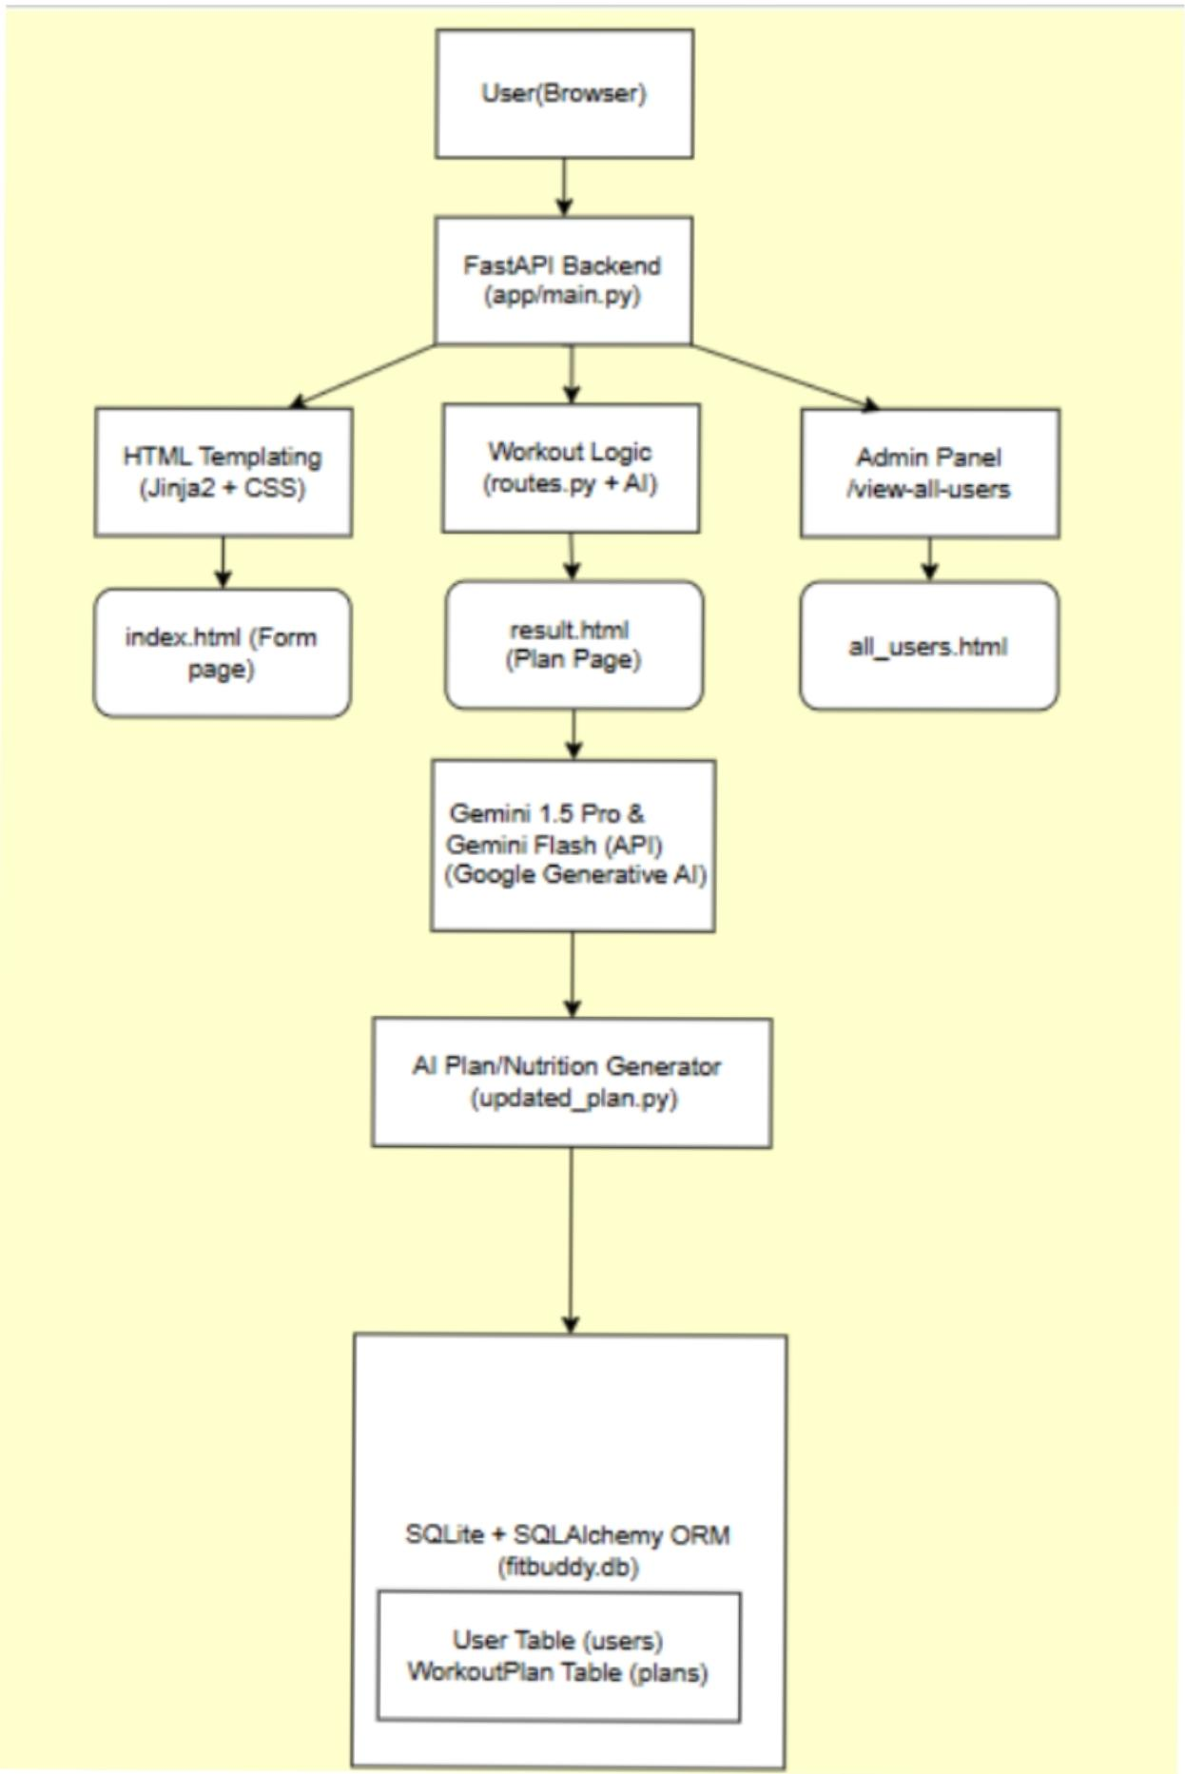
Figure 3.1 – FitBuddy AI architecture diagram

3.2 Module Design
Module | Responsibility
app/main.py | FastAPI app, static files and database initialization at startup
app/routes.py | Web form routes and JSON API routes
app/schemas.py | Pydantic models for input, plan structure and responses
app/models.py | SQLAlchemy models User and WorkoutPlan
app/crud.py | Database create, read and update operations
app/services/gemini_service.py | Gemini calls for workout, nutrition tip and plan revision
app/services/fallback_generator.py | Local plan and tip generator used when Gemini is unavailable
app/services/serializers.py | Conversion between plan objects and stored JSON

Method | Endpoint | Purpose
GET | / | Home page with planner form
POST | /generate-workout | Generate plan from the web form
POST | /submit-feedback | Update plan from the feedback form
GET | /view-all-users | Admin view of users and plans
GET | /api/health | Health check
POST | /api/generate-plan | Generate plan (JSON)
GET | /api/nutrition-tip | Nutrition / recovery tip for a goal
POST | /api/update-plan/{user_id} | Update plan with feedback (JSON)

3.3 UI Design
The interface has a Home page with the planner form, a Result page showing the 7-day plan, nutrition tip and feedback box, a Users page for the admin view and an Error page. The header provides Generate, Users and API Docs links, and the footer states that the content is general wellness guidance, not medical advice.

3.4 Data Design
Table | Fields
users | id, name, age, weight, goal, intensity, created_at, updated_at
workout_plans | id, user_id (foreign key to users), original_plan, updated_plan, nutrition_tip, generation_mode, created_at, updated_at

One user can have many workout plans. Plans are stored as JSON text.

3.5 Flowchart
The complete flowchart is provided as Flowchart.svg in the Project Design and Project Documentation folders.
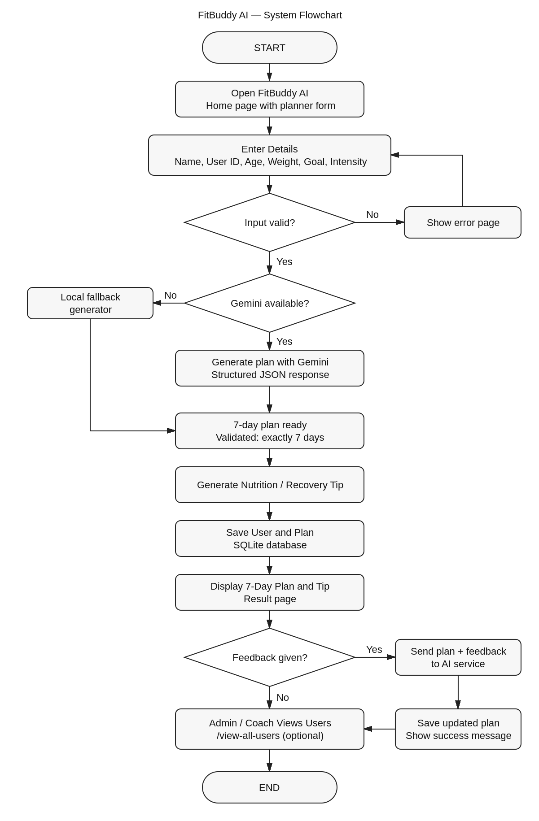
Figure 3.2 – FitBuddy AI system flowchart

3.6 Algorithm
- Start the application; the database tables are created.
- Display the Home page and collect user details.
- Validate the input; show the error page if invalid.
- Generate the 7-day plan with Gemini, or with the fallback generator if Gemini is unavailable.
- Validate that the plan contains exactly 7 days.
- Generate the nutrition or recovery tip.
- Store the user and plan in SQLite.
- Display the plan and tip.
- If feedback is submitted, revise the plan and store the updated plan.
- Display the updated plan with a success message.
- Allow the admin or coach to view all users on the Users page.

PHASE 4 – Project Planning

4.1 Work Breakdown Structure (WBS)
WBS No. | Work Package | Activities
1 | Project initiation | Idea selection, problem definition
2 | Requirements | Functional and non-functional requirements
3 | Design | Architecture, modules, database, UI, flowchart
4 | Development | Backend, services, Gemini integration, templates
5 | Testing | Pytest test cases, validation, fixes
6 | Documentation | Report, README, screenshots
7 | Demonstration | Working application, demo recording

4.2 Suggested Project Timeline
Period | Planned Work
Week 1 | Brainstorming and topic selection
Week 2 | Requirement analysis and initial design
Week 3 | Project structure, database models and schemas
Week 4 | Plan generation, nutrition tip and fallback generator
Week 5 | Gemini integration, feedback update and templates
Week 6 | Testing, debugging and UI refinement
Week 7 | Documentation, screenshots and report
Week 8 | Final demonstration and submission

4.3 Task Allocation
Team Member | Role / Responsibility
Mariya Darshini (25ds022) | Team Leader – overall coordination
S. Harini (25ds016) | Team member – development, testing and documentation support
R. Subhashri (25ds041) | Team member – development, testing and documentation support
S. Mythili (25ds024) | Team member – development, testing and documentation support

4.4 Milestones
- Idea and requirements finalized.
- Database, schemas and routes completed.
- Gemini integration with fallback completed.
- Templates and admin view completed.
- Pytest tests passed.
- Report and presentation prepared.
- Application demonstrated.

4.5 Risk Log
Risk | Level | Mitigation
Gemini API key missing or quota exceeded | High | Automatic fallback generator keeps the application working.
AI model names change | Medium | Model IDs are configurable in the .env file.
Invalid user input | Medium | Pydantic validation and error page.
AI returns an invalid plan | Medium | Response is validated against a schema requiring exactly 7 days; fallback is used on failure.
Health-related misuse | Medium | Prompts avoid medical claims and the interface shows a wellness disclaimer.

PHASE 5 – Project Development

5.1 Actual Project Structure
fitbuddy-ai/
├── app/
│ ├── __init__.py, main.py, config.py, database.py
│ ├── models.py, schemas.py, crud.py, routes.py
│ └── services/
│ ├── gemini_service.py
│ ├── fallback_generator.py
│ └── serializers.py
├── templates/ (base, index, result, all_users, error .html)
├── static/css/style.css
├── tests/ (conftest.py, test_app.py)
├── data/
├── .env.example, .gitignore, requirements.txt, pyproject.toml
├── start.ps1, start.bat
└── README.md

5.2 Backend Development
The backend is built with FastAPI. routes.py contains the web form routes and the JSON API routes. Pydantic schemas validate input (age 13–100, weight 20–400 kg, intensity low, medium or high) and the plan structure. SQLAlchemy models User and WorkoutPlan store data in SQLite, and crud.py handles saving, updating and reading users and plans.

5.3 Gemini AI Integration
gemini_service.py uses the google-genai SDK. Three functions call the model: generate_workout creates the 7-day plan as structured JSON, generate_nutrition_tip returns one short tip, and update_workout revises the plan using the user’s feedback. The workout and nutrition model IDs are read from the .env file, so they can be changed without editing code. If the API key is missing or the call fails, the local fallback generator provides the plan and tip.

5.4 Frontend Development
The frontend uses Jinja2 templates with a shared base.html and a single style.css. index.html holds the planner form, result.html shows the plan, nutrition tip and feedback box, all_users.html is the admin view, and error.html shows validation or processing errors.

PHASE 6 – Project Testing

6.1 Testing File
Testing is done with Pytest in tests/test_app.py, using FastAPI TestClient. conftest.py sets an empty Gemini key, enables fallback mode and uses a separate test database, so the tests run without a Gemini API key.

6.2 Test Case Table
ID | Test | Expected Result | Status
TC01 | Open Home page (GET /) | Status 200 and page contains FitBuddy | Pass
TC02 | Health check (GET /api/health) | Status 200 and status is ok | Pass
TC03 | Generate plan (POST /api/generate-plan) | Status 200, 7 days and a nutrition tip returned | Pass
TC04 | Update plan (POST /api/update-plan/1001) | Status 200 and updated plan has 7 days | Pass
TC05 | Nutrition tip (GET /api/nutrition-tip) | Status 200 and tip returned | Pass

6.3 Validation
- Age must be between 13 and 100.
- Weight must be greater than 20 and at most 400 kg.
- Intensity must be low, medium or high.
- Name and goal must not be empty.
- Feedback must have at least 3 characters.
- The generated plan must contain exactly 7 days.

6.4 Issues Found and Fixes
- The original project notes used the discontinued google-generativeai package and older model names. The implementation uses the current google-genai SDK with configurable model IDs.
- To avoid failures when the API key is missing or quota is exhausted, an automatic fallback generator was added.

6.5 Final Testing Evidence
The pytest run completed with all 5 tests passing (100%).
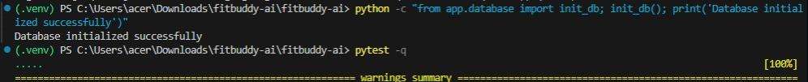
Figure 6.1 – Database initialization and pytest run

PHASE 7 – Project Documentation

7.1 Documentation Included
- Aim.txt – project aim.
- Algorithm.txt – step-by-step algorithm.
- Flowchart.svg – project flowchart.
- Results.txt – observed results.
- Project_Report.docx – full project report.
- FitBuddy_AI_8_Phase_Project_Documentation (this document, Word and PDF).
- README.md files in the project root and in the development folder.

7.2 Report Contents
The project report covers the project overview and description, four usage scenarios, main features, technical architecture, workout plan generation, nutrition tip, feedback-based revision, terminal and interface screenshots, and the conclusion.

7.3 Documentation Evidence
- GitHub repository: https://github.com/Mariyadarshini/fitbuddy-ai
- Architecture diagram and interface screenshots are included in the Design and Demonstration folders.
- The .env.example file is provided; the real .env file must not be uploaded.

PHASE 8 – Project Demonstration

8.1 Demonstration Flow
- Start the server with uvicorn app.main:app --reload.
- Open the FitBuddy AI home page in the browser.
- Enter name, user ID, age, weight, goal and intensity.
- Click Generate 7-Day Plan and review the plan.
- Show the nutrition or recovery tip.
- Enter feedback and click Update My Plan.
- Show the success message and updated plan.
- Open the Users page and the Swagger docs (/docs).

8.2 Final Output Evidence
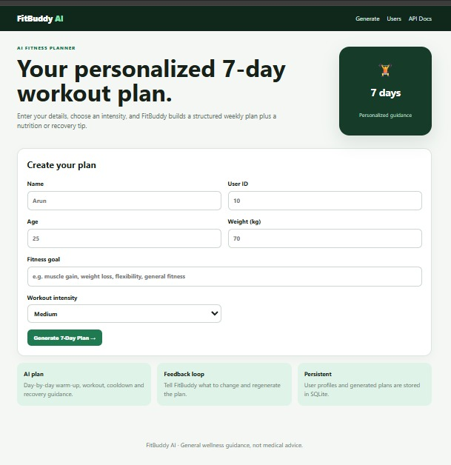
Figure 8.1 – Home page with planner form
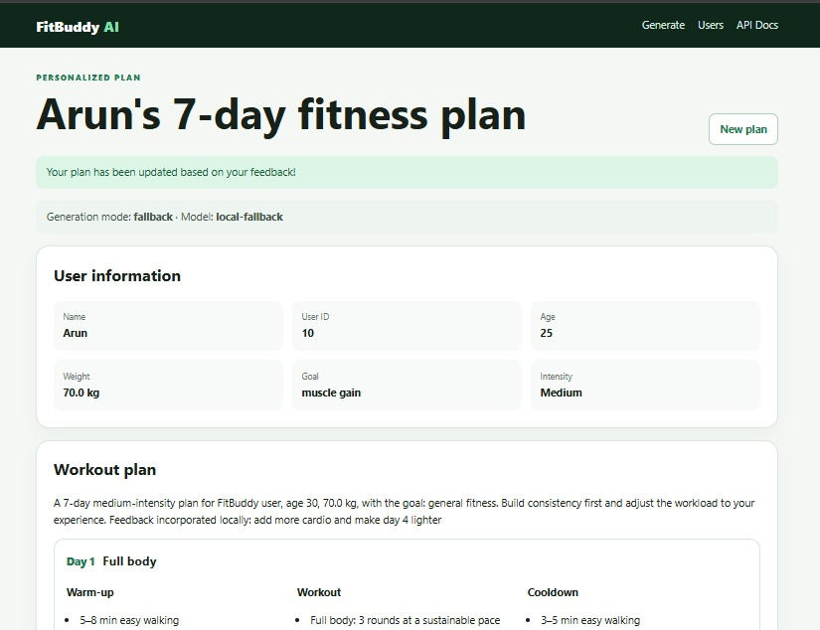
Figure 8.2 – Generated 7-day fitness plan
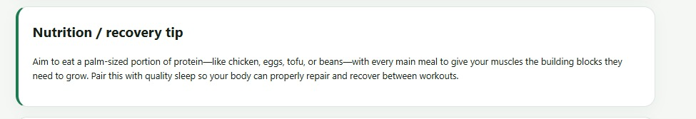
Figure 8.3 – Nutrition / recovery tip
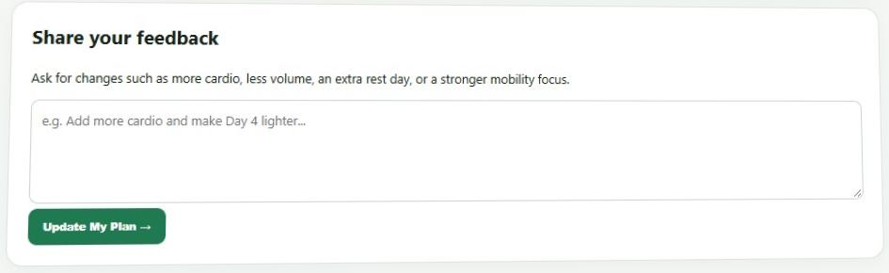
Figure 8.4 – Feedback form
Figure 8.5 – Plan update confirmation

8.3 Demo Video Link
The Google Drive demo video link is provided in Project Demo Link.txt in the Project Demonstration folder.

8.4 Final Demonstration Statement
FitBuddy AI demonstrates how Generative AI can be integrated into a FastAPI web application to provide personalized fitness plans. The project shows a complete workflow: collecting user details, generating a 7-day plan, giving a nutrition or recovery tip, storing data in SQLite and updating the plan from user feedback.

APPENDIX – Evidence Checklist
Evidence Item | Location | Status
Source code | 5. Project Development Phase / fitbuddy-ai | Included
Architecture diagram | 3. Project Design Phase / Solution Architecture.pdf | Included
Flowchart | Flowchart.svg (Design and Documentation folders) | Included
UI screenshots | 3. UI_Design and 8. Demo Screenshots | Included
Test file and pytest run | 6.Project Testing | Included
Project report | 7. Project Documentation / Project_Report.docx | Included
GitHub link | Project Demo Link.txt | Included
Demo video link | Project Demo Link.txt | Add link

